Recommendation to view the document in Web Layout and activate the Navigation Pane (Menu “View”)
The release of this audit program to parties external to IBM requires the written approval of the Chief Auditor.
This program is intended as a guide for assessing risk management in this process through the performance of an audit or a similar engagement. Risk management is the process to identify, manage, and control potential events in order to provide reasonable assurance related to the achievement of IBM’s business and control objectives. IBM's control objectives fall into five broad categories:

- compliance with external laws and regulations, as well as IBM policies and procedures
- accomplishment of business objectives
- reliable information for financial reporting and decision making
- efficient operations, and
- safeguarding both intellectual and physical assets.

The control assessment questions are intended to address process objectives from the categories above and the risks to achieving those objectives. Objectives and risks in the actual process under review may differ based on organizational, operational, regulatory, and economic factors. As such, individuals performing the engagement must formulate a test strategy based on risks relative to the actual process under review, regardless of whether the risks are identified within this program.

DATE CHANGED | SECTION # | SUBTITLE IN SECTION | CHANGED BY (NAME) | COMMENTS
December 2024 | ALL | ALL | Elena Jimenez de Scheer | Updated links, deleted outdated information, changed in style on the heading
April 2024 | All | All | Elena Jimenez de Scheer | Re-instate all Supplier Master File references and questions
November 2023 | Process and Objective |  | Elena Jimenez de Scheer | Created new section PLANNING: Serve-Serve Information
September 2023 | All | All | Elena Jimenez de Scheer | Removed all Supplier Master File references and questions
February 2023 | All | All | CA&AS | Converted from Notes into a Word document and into a Box folder

Table of Contents
PROCESS AND OBJECTIVE 3
PLANNING: Audit Program Risk Alignment 4
PLANNING: Data Analysis 5
PLANNING: Self-Serve Information 7
PLANNING: Reference Material 8
PLANNING: Fraud Template 9
CONTROL ASSESSMENT QUESTIONS 10
Key Control Question: 1. Supplier Master File 10
Primary Test: Vendor Master File Maintenance (SV001.P) 11
Key Control Question: 2. Processing Controls 13
Primary Test: Processing Controls (PC001.P) 14
Primary Test: Receipts and Payment Approvals (PC002.P) 17
Primary Test: Measurements and Exceptions Handling (PC003.P) 19
Key Control Question: 3. Accounting and Disbursement Controls 20
Primary Test: Ledger Controls (AC001.P) 21
Primary Test: Bank Reconciliations (AC002.P) 22
Primary Test: Disbursement Controls (AC003.P) 23
Key Control Question: 4. Application Management and Separation of Duties 24
Primary Test: Application Management (AS001.P) 25
Primary Test: Separation of Duties (AS002.P) 26
Key Control Question: 5. Business Continuity Planning 27
Secondary Test: Business Continuity Planning (BC001.S) 28
Backup Information 31
Instructions for WWBCIT 31
Instructions for OpenPages for BCP 33

PROCESS AND OBJECTIVE

For the purposes of this audit program, the accounts payable process includes maintaining vendor master file in system, receiving an invoice from a supplier, matching the invoice to purchasing commitment and receipt information, making a payment to the supplier, and recording the payment in financial records.

PLANNING: Audit Program Risk Alignment

Accounts Payable

Defined Risk Area | Audit Risk Level | Key Control Question | Test Number
Vendor Master File | High | Vendor Master File | SV001.P
Disbursement Controls | High | Accounting and Disbursement Controls | AC003.P
Processing Controls | Medium | Processing Controls | PC001.P, PC002.P, PC003.P
Application Management / Separation of Duties | Medium | Application Management and Separation of Duties | AS001.P, AS002.P
Accounting Controls | Low | Accounting and Disbursement Controls | AC001.P, AC002.P
Business Continuity Planning | Low | Business Continuity Planning | BC001.S

PLANNING: Data Analysis

Data analysis should be a part of every engagement where data is available in databases or data warehouses that can be accessed through query programs. This concept enhances the risk-based auditing approach, makes the audit process more efficient, and increases the productivity of the audit team. When the audit team does not have the skills required to perform these tasks, assistance should be sought from the Technology team.

All data used for analysis must be reconciled to an independent source so that the auditor has confidence that the universe is complete.

Data Source(s):

EPM S2P
As IBM’s platform for integrated enterprise data, EPM replaces static spreadsheets and slides with interactive self-serve dashboards. Source-to-Pay data is available on EPM. See also self-serve section of this document.

Common Ledger System - Financial Data Warehouse (CLS-FIW-LR)
The CLS-FIW-LR is a worldwide repository of the IBM accounting and planning information. It will be used to pull the Accounts Payable (A/P) ledger miscodes, manual journal entries, and payments for the audit.

Blackline
Blackline is an application used to report the reconciliation of each balance sheet account. It will be used to pull the monthly bank reconciliation and vendor liability reports for the audit.

Accounts Payable Utility (APU)
The APU tool is used for submitting requests for payments of paper invoices not related to Purchase Orders (POs). It is used in SAP and certain CAAPS countries. The APU tables will be used to pull non-PO related approvals. APU sampling should confirm proper documentation is in place, where applicable (as an example, the A/P procedure does not require documentation to be received in the North America A/P Center – it instead resides with the APU submitter)

Invoice Payment Verification Notification (IPVN)
The purpose of the IPVN is to ensure that IBM has received the goods/services for which we are paying. It is the responsibility of the recipients of the notifications to review the notifications and verify that the goods/services being paid for have been received/performed. If the requested goods/services have not been received, or if the invoice information is inaccurate, the requester or manager must contact A/P to correct or cancel payment of the invoice. A/P generates four types of notifications: negative notification, notification of invoice credit, notification of invoice cancellation and management summary report. A/P will validate that all IPVNs were timely distributed, and that any fallout was timely-actioned.

PLANNING: Data Analysis (continued)

The Data Analysis engagement procedures in the Audit Manual (link internal to CA&AS members only) provide further suggestions.
This table shows what data can be reviewed and analysis techniques.

Data to be Analyzed | Analysis to be Performed | Possible Anomalies | Concern
Changes and additions to the Vendor Master File | Review should confirm all vendor master records have been created / updated in line with the process. | Invalid changes or set-up to the vendor master file. | Invalid changes or set-up to the vendor master file could result in invalid payments or payment to the wrong vendor.
Electronic Notifications, Invoice Payment Verification Notification (IPVN) Process, and Management Summary | Validate that all notifications were timely distributed and any fall-out was timely resolved. | Disbursements inappropriately approved. | Not having disbursements properly approved could result in inappropriate payments, fraudulent transactions, financial losses, and vendor disputes.
Manual Entries  Note: A/P is collaborating with accounting for manual entries | Validate backup was correctly calculated and purpose clearly understood.  Verify manual journals were accurate, properly approved, and with clear and appropriate supporting documentation. | Inaccurate, incomplete, and unauthorized manual entries. | Inaccurate, incomplete, and unauthorized manual entries could impact the integrity of the ledger and result in financial misstatements and hinder detection of unauthorized transactions.

Please refer to the audit manager focal point for accounts payable, the enhanced audit team, and the Accounts Payable Enhanced Audit Requirements document for complete examples of the data that can be reviewed and analysis techniques for an accounts payable audit.

PLANNING: Self-Serve Information

Some information previously included in the Initial Data Request (IDR) items which continue to be relevant information in audits will now be extracted directly by the audit team. These are as follows:

Information previously in IDR | Instructional Materials to download information and applying for access to the source tool
- Mission statement and the current organizational chart  (Organization changes during the audit period should be presented during the kick-off meeting) | https://w3.ibm.com/w3publisher/global-accounts-payable
- Global vendor accounts payable manual (GVAPM) | https://w3.ibm.com/w3publisher/global-accounts-payable/policies
- List of family, and commodity codes and UNSPSC codes with their description, and those eligible for non-PO (PO exempt/IOI) process | PO: https://w3.ibm.com/w3publisher/gp-policies-and-practices/procurement-process/commodity-categorization  non-PO: https://w3.ibm.com/w3publisher/gp-policies-and-practices/procurement-process/non-purchase-order-process/non-po-categories
- EPM reports for the list of all payments to suppliers | S2P - Data  Alternative direct access to EPM Reports: EPM Procurement Audit Content  Or following the path “Team content / Co-creation / Source to Pay / Reports / Procurement Audits”
- Management Self-Assessment of Controls (MSAC)  - Risk Acceptance (RA’s)  - Key Control over Financial Reporting (KCFR) control points  - KCFR defects  - Any prior peer reviews, Proactive Business Control Reviews, ASCA, PwC or other external reviews  Any additional material related to control posture / risks should be shared during the opening conference | Instructions for WWBCIT
- Business Continuity Planning – Current business continuity plan (BCP).  - BCP incidents and corrective action plans  - List of employee’s part of the BC team to oversee the maintenance, invocation, and execution of the BC plan  - Documentation of the last two BCP testing | Instructions for OpenPages for BCP

PLANNING: Reference Material

The Global Accounts Payable (A/P) Policies and Practices called GVAPM (Global Vendor A/P Manual) is the source document for practices, and procedures related to the global A/P process. In addition, the following are key reference materials that are applicable to the A/P process:

- Corporate Instruction (IBM Corporate Documents - Corporate Instructions) :
  - FIN101 - Control of Disbursements
  - FIN151 - Information Integrity Application Systems Control and Auditability (ASCA)
  - CIO162 - Financially Significant Applications and Other Enterprise Applications
  - FIN182 - Management Self-Assessment of Control
  - LEG116 - Classification and Control of IBM Information
  - ET127 - Business Continuity Management

- Corporate Accounting Instruction IBM94-004 - Preparation and Approval of Journal Entries https://ibm.ent.box.com/s/narcwk1g28qav115b9xuzrjhxskb9fbl
- Global Procurement Policies and Practices - Procurement - Blue Book

- BPBC127 Guideline for Business Process - Area Business Continuity Planning GLOBAL BCM - BPBC127 Guideline
- IBM Export Regulation Office
- IBM Export Regulation Office - US Export Regulations Program (USERP)
- Denied Parties List (DPL) and Unauthorized Supplier List (USL) – Procurement - DPL and USL

PLANNING: Fraud Template

Fraud is any intentional act or omission designed to deceive others and resulting in the victim suffering a loss and/or the perpetrator achieving a gain. Fraud can be categorized into fraudulent financial reporting, misappropriation of assets, and improper or unauthorized expenditures.

Description of Fraud Risk | Typical Controls that should Detect the Fraud Risk | Testing Approach
Invalid changes or set-up to the vendor master file could result in invalid payments or payment to the wrong supplier. | IBM employee check, separation of duties and access control. | Review IBM employee HR records based on employee name against suppliers. If there is a match, is the employee's manager contacted to clarify whether the employee ever lived at the address given in the request? For US employees, if a potential match is found on w3People, is the HR (employee) database checked for name, address, and social security number (if available)? If a match is found for an individual, bank account should be checked against the payroll employee's records on file.  Review SOD and access controls process to determine that no SOD conflicts and unauthorized access remain undetected.  Review the change logs of vendor master file (VMF) and select a sample of new or changed VMF to test that the changes were authorized.
Unauthorized disbursement | Separation of duties and payment approval process. | Select a risk-based sample to determine that the controls in place were effective, complete and managed in a timely manner.  In addition, based upon defects identified establish if the current compliance testing was performed on such a way that these defects would be detected.

Note: The probability and impact will vary depending on the organization/business unit that is being audited.

CONTROL ASSESSMENT QUESTIONS

Key Control Question: 1. Supplier Master File

Objective:
Are payments made only to valid suppliers?

Risk/Exposure:
Adequate controls should exist over the updating and maintenance of vendor master file records and the responsibility for updating supplier information should be independent from purchasing, receiving and payment activities. In addition, controls should exist to ensure IBM does not transact business with IBM employees or with suppliers quoted on prohibited lists such as the denied parties list (DPL) or the unauthorized supplier list (USL). Procurement must review the USL prior to entering a commitment (via agreement or purchase order) with a new supplier. Payments made to invalid suppliers represent a financial loss to IBM and could result in violations of local laws or regulations. Doing business with suppliers on the DPL without adequate controls for identifying such parties and for review of proposed transactions subjects IBM to potential fines, penalties, loss of export privileges, and severe damage to IBM's reputation.

CONTROL ASSESSMENT QUESTIONS
Key Control Question: 1. Supplier Master File

Primary Test: Vendor Master File Maintenance (SV001.P)

Risk:
Invalid set-up or changes to the vendor master file (VMF) could result in invalid payments or payment to the wrong supplier.

Objective:
To confirm whether sufficient controls exist to maintain the integrity of the VMF.
To confirm that adequate controls by the VMF owning organization over the updating and adding of VMF records and that payments are made only to valid suppliers.

Approach:
Review procedures for additions, changes, and deletions to the file of valid suppliers.
Review procedures to identify and eliminate duplicate supplier records.

- Are job responsibilities adequately separated? Individuals responsible for updating vendor master file records should not be involved in the placing of orders, processing of invoices and payments, or preparation of cheques.
Run a report to identify vendor records added or updated in the vendor file with payments that were incurred during the audit period. Select a sample of vendor additions and changes based on the transaction amount, payment method, blocking flags, discount flag, invoice status, vendor name, and payment term, etc. to test against the following controls.

- Do controls exist to check proposed suppliers against DPL and USL? According the GVAPM and IBM Procurement policies, A/P should perform back-end checks against DPL (whenever the DPL is updated) and USL (monthly). It is the responsibility of requester to perform these checks. Are these controls executed correctly?
- Do procedures exist to validate the appropriateness of requests for vendor master file updates? Are supplier details verified to supporting documentation/appropriate data sources? Are management approvals obtained when dealing with exceptions?
- Are proposed suppliers checked against employee/ payroll records based on employee name? If there is a match, is the employee's manager contacted to clarify whether the employee ever lived at the address given in the vendor request? For US employees, if a potential match is found on w3People, is the HR (employee) database checked for name, address, and social security number (if available)? If a match is found for an individual, auditor should check bank account against the payroll employee's records on file.
Apply additional pattern matching techniques to find similar names in employee population which might represent potential matches to vendor lists.

CONTROL ASSESSMENT QUESTIONS
Key Control Question: 1. Supplier Master File
Primary Test: Vendor Master File Maintenance (SV001.P)
(Continued)

- Are proposed suppliers checked against existing vendor records to identify potential duplicate entries? In case a potential duplicate is found, and no supporting documentation is available, is the supplier contacted to clarify the potential duplicate entry prior to processing?
Apply additional pattern matching techniques to find similar names and addresses which might represent duplicates. SPI - Bank account numbers might not be available in all cases.
The D&B (Dunning number) a nine-digit unique identifier that helps establish an exclusive identity for businesses. This is not contained in the vendor table but is available at Procurement because the Dunning number is part of the vendor qualification process. Other information to consider for finding duplicate vendor records are the Tax id # or VAT #, and payment method (those are included in the VMF). Please note that duplicate vendors may exist due to factors like payment methods and e-invoice enablement.
- Check that details loaded into the vendor master file match to the supporting documentation (bank account details, supplier name, and address) and that adequate audit trails exist to substantiate all updates. Is a report run to check pay term record mismatches between VMF and actual payment?

- Determine whether adequate controls exist over mass vendor master file updates (e.g., transferring supplier records from a subsidiary's accounts payable system).
Run a query to identify suppliers on the vendor master file where there has been a lack of payment activity for the preceding 30 months. Select a sample to test:
- Was the deletion or blocking request performed timely?
- Verify if there was any open purchase order for a supplier that was deleted.

Run a query to identify suppliers on the vendor master file where there has been a lack of payment activity for the preceding 18 months. Select a sample to test:
- Was the inactivation request performed timely?
SAP Specific Controls:

- Is the duplicate invoice flag (CHK D.INV) switched on for each vendor record in SAP? This flag instructs SAP to perform duplicate invoice validation checks.
- Are procedures in place by the GVMG team to control and review generic vendors or "one time" vendor records? These records allow supplier details such as name, address, and bank details to be manually entered during invoice processing.
- Do controls exist to ensure that all vendor records contain all required information? This includes accounting data, reconciliation accounts and payment terms from the financial accounting view, and order currency and minimum order value from the purchasing view.

CONTROL ASSESSMENT QUESTIONS

Key Control Question: 2. Processing Controls

Objective:
Are payments to suppliers timely, accurate, consistent with purchasing commitments, and properly approved?

Risk/Exposure:
Weaknesses in processing controls could result in duplicate payments, payments being made early or late, for incorrect amounts, exceeding the purchasing commitments, or for goods and services not received. In addition, processing errors could lead to supplier dissatisfaction. Adequate payment controls should exist to ensure all payments made to suppliers are valid and properly approved.

CONTROL ASSESSMENT QUESTIONS
Key Control Question: 2. Processing Controls

Primary Test: Processing Controls (PC001.P)

Objective:
To confirm that supplier invoices are processed in a timely and accurate manner, and to determine the adequacy of controls over the receipt of electronic data.

Approach:

Review the process for receiving and processing of supplier invoices.
PO invoice payments universe analysis and sample selection:

- Identify payments and determine whether they were timely based on the payment terms and conditions. Calculate the discount amount and compare net amount to gross amount to determine accuracy of discount.
- Identify POs whose total payments (including payments prior to the start of the audit period) exceeded the PO commitment amount and have been forced paid. Identify invoices created prior to the associated PO issue date.

- Identify invoices where withholding tax amount was non-zero. Identify invoices where the gross amount was not the same as the net amount combined with withholding tax amounts.
- Also identify any PO disbursements that did use an existing non-PO commodity code.

Areas for review:

- Are there valid original supplier invoices addressed to IBM (or an IBM subsidiary or newly acquired acquisition), date and time stamped, and sequentially processed into the accounts payable system?
- Determine whether data entry revalidation checks are performed to confirm key invoice details, for example, vendor invoice number, invoice date, amount, and currency. Do controls exist to ensure that invoice line amounts, discounts taken, and any applicable sales taxes agree to the total invoice value processed?
- Determine that the form of invoice (PDF, electronic, etc) is a legally accepted form of documentation per country law/statutory tax requirements. Validate that the information on the invoice is complete and in line with country law/statutory tax requirements (address, VAT, etc).
- Are procedures in place to identify duplicate payments? Determine whether controls exist over the processing of copy invoices or supplier statements. To identify potential duplicate payments for testing, sort the invoice amount by supplier and by invoice number. Check if (1) a supplier has several invoices with identical amounts, and (2) a supplier has the same invoice amount appearing under several invoices with similar invoice numbers.
- Determine if validation routines against the vendor master file records exist to confirm supplier details (name, address and bank details). Can the master file records be overwritten?
- Do the payment terms in the PO match the CAAPS system input?
- Do controls exist to validate the invoice against purchase order commitments, including purchase order number, quantity, unit and total price, start and end date of service rendered, and payment terms?
- Are procedures in place to accept terms for early payment discounts where these are favorable?

CONTROL ASSESSMENT QUESTIONS
Key Control Question: 2. Processing Controls
Primary Test: Processing Controls (PC001.P)
(Continued)

- Are procedures in place to control the use of debit memorandums? Where these are used to offset against supplier payments, are they tracked and followed through to resolution with the supplier? Do controls exist to prevent the processing of a duplicate debit on receipt of the subsequent credit note from the supplier?
- Determine whether sufficient audit trails exist including retention of supplier invoices and records showing processing transaction history.
- Are procedures in place to review invoices with expedited payment terms to ensure these terms are warranted prior to payment processing?
Non-PO invoice payments universe analysis and sample selection:

- Identify non-PO disbursements that used existing PO commodity codes. Non-PO commodity codes are associated with disbursements only and are not necessary transactions such as adjustments, credits, incoming checks, and rebate/refunds activity. Identify cases where Procurement involvement may have been required for non-PO disbursements with incorrect commodity codes.
Assess whether required approvals were based on clip levels. Identify approval exceptions. Smart match payment approvers to People to determine manager status.
- Identify invoices where tax is withheld (withholding tax amount was non-zero). Identify those invoices where the gross amount was not the same as the net amount combined with withholding tax amounts.
- Review the accurate discounts that were taken for non-PO disbursements. Identify payments and determine whether they were timely based on the payment terms and conditions. Calculate the discount amount and compare net amount to gross amount to determine accuracy of discount

Areas for review:

- Check activity based on transaction amount, payment method, and commodity code, by vendor. Assess whether required approvals were based on clip levels. Determine appropriateness of invoices against similar units. Non-PO expedite documentation is maintained by the responsible A/P group.
- Determine activity based on transaction amount, taxable and non-taxable, vendor, and commodity code.
Validate tax withholdings were accurate and were processed as required by local regulations.

- Determine that the form of invoice (PDF, electronic, etc.) is a legally accepted form of documentation per country law/statutory tax requirements. Validate that the information on the invoice is complete and in line with country law/statutory tax requirements (address, VAT, etc.).
- Examine activity based on payment terms (particularly those with expedited terms), transaction amount, transaction date, commodity code, and invoice numbers.
- Identify cases where Procurement involvement may have been required for non-PO disbursements with incorrect commodity codes.
CONTROL ASSESSMENT QUESTIONS
Key Control Question: 2. Processing Controls
Primary Test: Processing Controls (PC001.P)
(Continued)

- Compare the invoice description to the commodity code definition and sample those invoices where there is an inconsistency between the description and the (it is the responsibility of the requester and authorized approver per FIN101 to ensure that the correct commodity code was selected). Check to affirm that the approvals match FIN101 requirements (such as a requirement by local country financial delegation).
SAP Specific Controls: Are ‘parked’ invoice documents reviewed and processed in a timely manner to ensure that incomplete or unposted vendor invoices are resolved without delay? What controls exist over the direct entry of invoices into the FI-AP module as these invoices by-pass validation checks against purchase orders and goods receipt controls.

CONTROL ASSESSMENT QUESTIONS
Key Control Question: 2. Processing Controls

Primary Test: Receipts and Payment Approvals (PC002.P)

Objective:
To confirm that payments to suppliers are consistent with purchasing commitments, are properly approved, and that goods and services have been received.

Approach:
Review established limits for making payments exceeding the purchase commitments. Do controls exist to prevent payments exceeding the allowable variances and are these referred to procurement for approval?
Review the current process for verifying goods receipt or service confirmation. In cases where the requisitioning of purchases and verification of goods receipt/confirmation of services cannot be separated (e.g., in the absence of a designated receiving area), check if there are adequate secondary controls to safeguard against inappropriate payments.
Invoice Payment Verification Notifications (IPVN): Where the organization operates an invoice payment verification notification process (IPVP), determine the adequacy of approval procedures. Per Corporate Instruction FIN 101 the auditable document in negative confirmation cases is the IPVN. In particular:

- IPVN issued in sufficient time to allow review prior to payment of the invoice?
- For services, is the receiver of the IPVN validating the start and end dates on electronic PO invoices to the labor hours and timecards of services/subcon labor the requester received.
- Is the requester’s manager or the manager of the cost center absorbing the charges issued with summary reports providing visibility of IPVN’s processed for their departments? Review the IPVN distribution process. Were IPVNs timely distributed and any fallout timely resolved.
- Are all IPVN responses requesting blocking of invoice payment promptly processed? In addition, are blocked invoices tracked and reported to ensure prompt resolution?
- Are IPVN logs maintained demonstrating that notices were issued where required?
- Ensure procedures exist to identify and action all instances where IPVN do not reach the intended recipient. Are ‘fall-out’ rates monitored and investigated?
- For invoices not covered by a purchase order or contract, are the correct levels of approval per FIN 101 requirements obtained prior to payment of the invoice? Are procedures in place to verify the authenticity of approvers (e.g., compliance testing)? If an A/P location utilizes the positive confirmation process for non-PO invoices, the requester is responsible to verify if goods were received or services were performed, and the invoice amount is correct.

- Are procedure in place to manage invoices awaiting positive confirmation before payment?
- Are invoices below clip levels requiring additional management approvals, randomly sampled to identify process circumvention?
- If not included in purchase order, are prepaid freight charges short paid on the invoice and reason for short payment sent to the supplier? Are upfront/advance payments included in purchase order and clearly spelled out in IPVN verification?

CONTROL ASSESSMENT QUESTIONS
Key Control Question: 2. Processing Controls
Primary Test: Receipts and Payment Approvals (PC002.P)
(Continued)

- Do controls exist to prevent payments exceeding the purchase order and/or invoiced amounts?

- If there are legal requirements to withhold tax from certain categories of suppliers (e.g. overseas or non-incorporated suppliers) or if there are administration requirements to be met to be exempt from tax liabilities (e.g., duty drawback), do procedures exist to comply with requirements prior to supplier payment? Were all tax codes in the tax table up to date? Request a copy of all the tax codes in CAAPS. Ask the country tax managers to confirm if there were any tax rate changes. If so, find out the timing of such changes.
- Verify if the changes had been reflected in the CAAPS tax table.
- Select a judgmental sample of the changed tax rates and select invoices close to the time of the changes to verify if the invoices were paid based on the updated tax rates.

- For the sample selected in PC001.P, verify whether payment controls were adhered to and investigate all exceptions. In addition, undertake specific testing where risks have been identified; for example, run a query to identify all payments made exceeding the purchase order commitments and determine whether required approvals were obtained prior to payment.

- SAP Specific Controls: Supplier invoice is automatically blocked for payment if the invoice amount exceeds the system parameters. In the SAP Production system where the three-way match process (PO, invoice, goods receipt) must happen before an invoice is paid.
Have appropriate tolerance limits been configured in SAP to ensure blocking of invoices during invoice verification when purchase commitment levels are exceeded? Have appropriate tolerance limits been set for goods receipts variances? Is it possible to override invoice blocks? Are quantity tolerance levels for mismatches set to zero when invoice quantity exceeds receipt quantity?

CONTROL ASSESSMENT QUESTIONS
Key Control Question: 2. Processing Controls

Primary Test: Measurements and Exceptions Handling (PC003.P)

Objective:
Are measurements in place to provide management with visibility of operational efficiency? Are exception conditions identified, reported, and properly handled?

Approach:
Do measurements exist to assess operational efficiency and process exceptions? Confirm processing targets and service level commitments and ascertain whether these are being met. Suggested areas to review are:

- Invoice payment timeliness
- Invoices returned to vendors
- Invoice processing accuracy
- Level of duplicate payments
- IPVN (Invoice Payment Verification Notices) rejections
- Unresolved supplier claims and debit balances
- Payment terms overrides (e.g., expedited payments)
- Are aging of open and unblocked invoice queries included in the payment exception report analysis and monthly operational charts?
- Aging of invoices blocked for payment
- Aging of invoices awaiting positive confirmation
Where performance levels are below target at a Geo level (e.g., A/P Center level), investigate reasons why and determine whether action plans have been implemented to correct defective performance.
Determine whether procedures exist to track and resolve invoice queries and referrals to other departments (e.g., procurement). Are referrals monitored to ensure prompt resolution? Note: It is the responsibility of IBM Procurement to timely resolve buyer referrals which are those invoices blocked from payment due to unit cost or quantity discrepancies between the invoice and the purchase order.
Review process for ‘blocking’ payment of invoices, for example because of an invoice payment verification process confirmation rejection. Are all blocked items followed through to resolution? Are aged items measured and reported to management? Can ‘blocked’ invoices be overridden without appropriate review and resolution?
Review the level of urgent payments, final demands, and legal situations. Investigate reasons for exceptions and determine whether process deficiencies exist.
Determine whether a process exists to handle supplier claims. Are claims for short-shipments and returned goods properly handled and resolved? Verify that credit notes are received and processed on a timely basis and are deducted from subsequent payments.

CONTROL ASSESSMENT QUESTIONS

Key Control Question: 3. Accounting and Disbursement Controls
Objective:
Do financial controls ensure that all disbursements are valid and are properly recorded in the accounts?

Risk/Exposure:
Incorrect recording of disbursements could result in inaccurate financial records. Exceptions, variances, and aged items in financial records could indicate deficiencies in operating controls or may point to irregular activities. Disbursements booked to incorrect ledger codes could result in inaccuracies in subsequent cost / revenue matching processes.

CONTROL ASSESSMENT QUESTIONS
Key Control Question: 3. Accounting and Disbursement Controls

Primary Test: Ledger Controls (AC001.P)

Risk:
Unauthorized booking may result in misrepresentation of IBM’s financial reporting and hinder detection of fraudulent transactions.

Objective:
To confirm that payments are recorded accurately and on time in the financial records.

Approach:
Review the sub-ledger to ledger reconciliation process for the accounts payable feeder input to the general ledger. Select a sample of period end feeder control reports and review against the following attributes: reconciliation performed within accounting cut-off deadlines; reconciliation performed accurately and properly approved; reconciling items measured, reported, and resolved in a timely manner.
Identify the existing ledger accounts for accounts payable activity (e.g., trade creditors, accounts payable control account, suspense accounts, default accounts). Select a sample of these and verify that reconciliations were performed as required each period end. It is recommended to select 3 to 4 consecutive months. Suggested attributes: reconciliation performed on time, accurately and properly approved; reconciling items measured, reported, and resolved in a timely manner; and variances are supported.
Sample manual journal entries to the ledger and verify that the corresponding accounting entries are accurate, properly supported and approved, and are substantiated by supporting documentation.
Ensure balance sheet accounts are in accordance to the Standard for Reconciliations of Balance Sheet Accounts. Ensure: All balance sheet accounts have been formally reviewed and signed-off on a timely basis. Reconciliations must be prepared in a manner that an independent observer can: 1. readily identify outstanding items or incorrect items included in the general ledger balance as well as the aging of these items. 2. readily understand the actions being taken to clear outstanding items or incorrect items through comments on the reconciliation.
Verify input/output controls from CAAPS to ledger exist, amounts and number of records reconciled, reviews are documented and reviewed by management.
Determine whether offsets are made between the purchase ledger and sales ledger (netting). Offsets should be supported by prior written agreement from suppliers.
Confirm whether separation of duties is adequate to prevent irregular activities. Individuals involved in the processing of supplier invoices and the preparation of payments should not have responsibility for account reconciliations and should not have access to the general ledger.
Undertake additional testing where risk areas have been identified (e.g., test a sample of manual journal entries, or A/P miscodes).

CONTROL ASSESSMENT QUESTIONS
Key Control Question: 3. Accounting and Disbursement Controls

Primary Test: Bank Reconciliations (AC002.P)

Risk:
Incorrect analysis and controls for banking reconciliations could result in financial loss to IBM and delay detection of fraudulent transactions.

Objective:
To determine that bank accounts owned by Accounts Payable are reconciled to corresponding ledger accounts.

Approach:
Obtain a list of bank accounts used for accounts payable.
For each account, review the bank-to-ledger reconciliations for a period of at least two consecutive months. Reconciliations should be performed within accounting cut-off deadlines to ensure any corrective entries are reflected within the correct accounting period. Confirm that reconciliations are timely and accurate, properly approved by an authorized approver; and action plans are in place for any variances. In addition, check that reconciling items are measured, reported, and cleared in a timely manner. Verify that the individual responsible for bank reconciliations is not also responsible for accounts payable or disbursement activities.

CONTROL ASSESSMENT QUESTIONS
Key Control Question: 3. Accounting and Disbursement Controls

Primary Test: Disbursement Controls (AC003.P)

Objective:
To determine that there is adequate control over disbursement activities, including the handling of negotiable instruments.

Approach:
Review procedures for raising the supplier payment proposal from the accounts payable system. If required, is the proposal validated and approved by an authorized approver?
Determine the number of disbursement options in use (e.g., cheques, postal transfer forms, bank drafts, wire transfers, electronic funds transfer, foreign currency payments).
Select one or more samples from the various disbursement options, considering values disbursed and the level of risk. Suggested attributes: timeliness of disbursement; disbursement amount matched to processing totals and supporting documentation (payment proposal); disbursement approved by an authorized approver(s).
If disbursements are consolidated for payment (for example, by electronic funds transfer) review the related processing controls. Suggested items to review: approvals, reconciliation to payment proposal, confirmation of receipt and processing by bank, data transmission and password controls. Select a sample of detailed payments from the consolidated disbursement and verify to the payment proposal at an invoice level.
Review procedures for handling cheques and other negotiable instruments. Do controls exist over the ordering, receipt, inventory and custody of cheques and blank forms? These should include: restricted access to stocks of cheques; sequence controls to account for usage; independent monthly reconciliations of cheque stocks to new cheque issues and payments made; controls over access to approval signature plates; separation of duties.

- Review log of monthly reconciliation of blank check forms - review beginning and end check numbers.
- Review bank acknowledgement files and reconcile to the payment report (bank reference and IBM reference numbers).
- Ensure process in place to recover funds and payments was correct. If not, there was appropriate documentation in place to recover funds.
- Review duplicate payments from SAP to ensure appropriate action had been performed.
- Review desk procedures and supporting documentation.
- Validate all control points, as defined by the Accounts Payable processing center, for their disbursement process.
- Validate the sampling methodology, as defined by the Accounts Payable processing center, for their self-assessment of payment activities.
Review procedures for handling returned payments. Suggested items to review: timeliness of deposit, accounting entries, documentation of reason, corrective action taken, change to vendor master file made if appropriate, duties properly separated. Are returned payments logs maintained?
Verify supplier batch payout amount ties out to the amount paid out by the bank.

Analyze payments executed directly by treasury outside of the accounts payable process. Verify that the payment qualified for the exceptional process, the required approval was obtained, and the invoice was recorded in the A/P systems as per process.
CONTROL ASSESSMENT QUESTIONS

Key Control Question: 4. Application Management and Separation of Duties

Objective:
Are job responsibilities separated and system access capabilities restricted in a way which will prevent a person from circumventing established controls?

Risk/Exposure:
Application activities not in accordance with the Information Technology (IT) Security Standards, Use Guidelines for IBM employees, and the IBM Security Manual could result in unauthorized payments, impair IBM’s ability to provide services as committed, customer dissatisfaction, and financial loss.

An individual with job responsibilities and/or system accesses which would permit to initiate and hide irregular activities could make fraudulent payments which result in financial loss.

CONTROL ASSESSMENT QUESTIONS
Key Control Question: 4. Application Management and Separation of Duties

Primary Test: Application Management (AS001.P)

Objective:
To review that ASCA certification was obtained, if required; effective process controls were implemented for managing all application changes and releases; and a problem management process was put in place. Local management must conduct an annual, formal review of their spreadsheet inventory and confirm ASCA applicability.
To verify that management controls and authorization of all access to the application and data can be demonstrated with management awareness.

Approach:
Take sample of individuals with access to system. Review access and update procedures and validate if accesses were granted on authorized requests.
Verify if system accesses stated in the SOD assessments matched the system access logs.
Check that access for those leaving, plus all role changes, were removed or updated in a timely manner.
Verify if quarterly employment verification (QEV) and yearly continuous business need (CBN) reviews were performed.

CONTROL ASSESSMENT QUESTIONS
Key Control Question: 4. Application Management and Separation of Duties

Primary Test: Separation of Duties (AS002.P)

Objective:
To validate that no person has job responsibilities or system access capabilities which could allow established controls to be circumvented per Corporate Instruction FIN 182 requirements.

Approach:

Review procedures to ensure separation of duties exist and conflicts are identified and mitigated through appropriate secondary controls, eliminated, or accepted based on risk severity. In addition, ensure responsibilities are adequately defined. Furthermore, validate that all employee tasks accurately reflect the activities being performed and are updated accordingly when responsibilities change. Specifically, review the job responsibilities assigned in the areas of purchasing and accounts payable, including supplier verification, invoice data input, accounting, and disbursements for possible separation of duties conflicts. Note the experience levels of each employee involved in the process including time in their present position, time with IBM, and verify vacation usage for all employees involved in accounts payable and disbursement transactions.
If the accounts payable system operates in an SAP environment, a detailed review of access profiles is critical to understanding system access capabilities and separation of duties.

Perform inquiry investigation of secretaries and any other personnel suspected of using a manager's personal identification code (PIC) or who has access to a manager's w3id and password to approve employee payables, other disbursements, or documents.
Identify possible fraud scenarios based on knowledge of the process, job responsibilities, and system access capabilities and investigate all possible exposures. Examples of possible fraud scenarios in the accounts payable environment include:

- Requests to change a supplier's name, remit-to address, or bank account details are not validated with the supplier or other reliable source. An individual mails in a supplier name, address or bank account change which will divert future payments intended for that supplier to himself. The exposure is greatest in countries where banking laws do not require strict controls on cheque endorsements, automatic deposits, and identity checks when bank accounts are opened.
- A programmer has the capability to make unauthorized changes to the supplier and purchasing files. The programmer creates a supplier, creates a purchase order, marks the goods received, and submits a falsified invoice. The payment is made automatically.
- An aged, open purchase order for an inactive supplier exists. A person with knowledge of this purchase order has the capability to update the supplier file and receiving information; and could make the necessary updates and submit a falsified invoice. The payment is made automatically.

CONTROL ASSESSMENT QUESTIONS

Key Control Question: 5. Business Continuity Planning

Objective:
To determine if process owners have developed, reviewed, and tested business continuity plans (BCP) so that in the event of natural or man-made disasters, pre-defined plans can be executed to maintain business operations.

Risk/Exposure:
Any material disruption of business operations due to natural or man-made disasters can lead to significant financial loss not only to IBM but potentially also for IBM's customers. In the accounts payable process this could impact our payments to suppliers. Many business processes have been centralized, and often operations are conducted in locations which may be susceptible to business disruption. As a result, it is important that business and process owners have developed plans to maintain continuity of business operations in those centralized operations.

CONTROL ASSESSMENT QUESTIONS
Key Control Question: 5. Business Continuity Planning

Secondary Test: Business Continuity Planning (BC001.S)

Note: Business continuity risks become increasingly important in the environment where there are centers of excellence and multiple countries are supported by one center. This should therefore be an important test and considered primary in that environment. IT testing for disaster recovery is handled by the IT audit teams.
Objective:
To determine if process owners have developed, reviewed, and tested business continuity plans (BCP) so that in the event of natural or man-made disasters, pre-defined plans can be executed to maintain business operations.

Approach:
A guideline has been put in place for process owners providing guidance on business continuity planning (BCP). It should be noted by the audit team that this is a guideline rather than a specific instruction. However, it will act as a guide for you to understand whether key risks have adequately been considered for BCP and enable you to make an informed judgment regarding the risk mitigation in place. Different processes will have their own unique risk profiles regarding the probability and impact of an interruption to business operations. For example, the probability and impact of a business interruption for a process which has been centralized for multiple countries in a location with less-developed infrastructure is likely greater than that of a process supporting only a single country in location with robust infrastructure. As such, auditor judgment will be required to determine how important BCP is for a particular process, as well as to determine the reasonableness of any plans that have been designed by the process owners.
In the initial data request information ask for the process owner to confirm what plans have been implemented to ensure business continuity in the event of a natural or man-made disaster. Review that non-I/T process elements have been adequately considered in the BCP.
The following list of questions has been designed based on the BPBC127 Guideline for Business Process - Area Business Continuity Planning:

- Has management assessed the risk to business continuity (BC) and identified the key business processes and activities that require formal business continuity planning based on impact to the business.
- Identification and prioritization of business processes’ activities in addition to prioritization done through by the Enterprise Process Owner (level 3 plans)
- Understanding and documentation of the potential impact (financial, operational and reputation) to IBM from business disruptions from uncontrolled, non-specific events
- Identification of the legal and regulatory requirements for the institution's business functions and processes
- Review and approval from senior management
- For critical business areas and processes, has the maximum acceptable outage (MAO) been established and considered in the BC plan?
  - Estimation of maximum allowable outage (MAO), based on the “acceptable level” of losses, associated with the institution's business functions and processes
  - Estimation of recovery time objectives (RTOs), recovery point objectives (RPOs), and Maximum Tolerable Downtime (MTD) of applications and supporting technology required for business operations
  - f applicable, recommended critical path recovery order
  - Reconciled with agreed IT recovery priorities (Business Criticality Values, RTO/MTD)

CONTROL ASSESSMENT QUESTIONS
Key Control Question: 5. Business Continuity Planning
Secondary Test: Business Continuity Planning (BC001.S)
(Continued)

- For business areas and processes where there is a business continuity risk, has the BC Plan been created, reviewed, and approved by management?
  - The organization shall establish documented procedures for responding to a disruptive incident and how it will continue or recover its activities within a predetermined timeframe.
  - Top management shall review the organization’s BCMS, at planned intervals, to ensure its continuing suitability, adequacy and effectiveness.
- Does the Plan document the specific continuity and recovery actions for all four impact scenarios (workforce, workplace, IT, and regional) that will need to take place to mitigate risk to the business if the impact lasts longer than the documented business’ maximum acceptable outage?
  - Flexible to respond to unanticipated threat scenarios and changing internal conditions.
  - Focused on the impact of various threats that could potentially disrupt operations rather than on specific events.
  - Effective in minimizing service disruptions and financial loss through the implementation of mitigation strategies.
- Does the BC plan clearly identify dependencies such as site resources, IT, suppliers, process interdependencies, partners, non-IT services and been reviewed and synchronized with the appropriate crisis management team?
  - An effective BCP coordinates across its many components, identifies potential process or system dependencies, and mitigates the risks from interdependencies.
- Is there an established, management-endorsed business continuity team to oversee the maintenance, invocation, and execution of the BC plan?
  - Defined roles and responsibilities for people and teams having authority throughout an incident
  - Additional teams as necessary to facilitate recovery execution per the chosen strategy
- Are personnel aware and educated on the plan, strategy and roles?
  - Business continuity training should be an integral part of the BCM
  - Comprehensive training program should be developed for all employees, conducted at least annually, and kept up to date to ensure that everyone understands their current role in the overall recovery process.
- An audit trail should be maintained to document management's training efforts.
- Is there a regularly executed process for validating the Plan through tests including key elements such as people, technology (data, systems, applications, and telecommunications), and locations that house staff and technology to ensure fit for purpose and alignment with current risks?
  - Tests should be based on appropriate scenarios that are well planned with clearly defined aims and objectives that promote continual improvement
  - Produce formalized post-exercise reports that contain outcomes, recommendations, and actions to implement improvements and are reviewed with management
  - Tests are conducted at planned intervals and when there are significant changes within the organization or to the environment in which it operates.

CONTROL ASSESSMENT QUESTIONS
Key Control Question: 5. Business Continuity Planning
Secondary Test: Business Continuity Planning (BC001.S)
(Continued)
- FOR COMMERCIAL CONTRACTS: Where IBM has customer contracts including business continuity planning, have BC plans been implemented in accordance with contractual obligations?
FOR CUSTOMERS WITH REGULATORY REQUIREMENTS: Does the plan accommodate and account for the any unique rigor or accommodations for the regulatory body.
  - Adherence with contractual obligations contained in the IBM Responsibilities section of the Schedule or similar agreement. Including communication, recovery parameters, specialized technical designs.
  - Special considerations to meet unique regulatory requirements (HIPAA – US Healthcare has unique wording on backup, protection, and availability of data).

Backup Information

Instructions for WWBCIT

Access to WWBCIT using the following link: https://w3.ibm.com/finance/controls/wwbcit/index.wss
Go to “Processes, key controls and samples”.
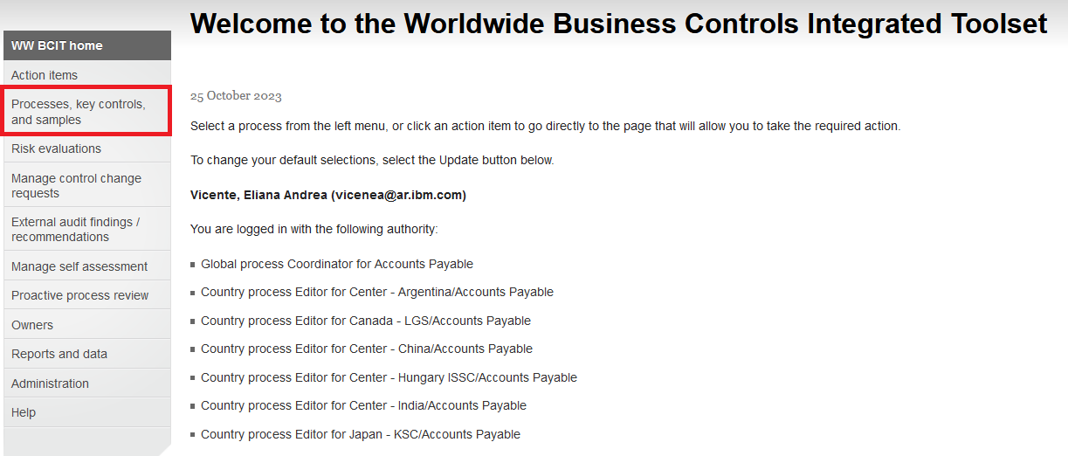

Then select “Process documentation”
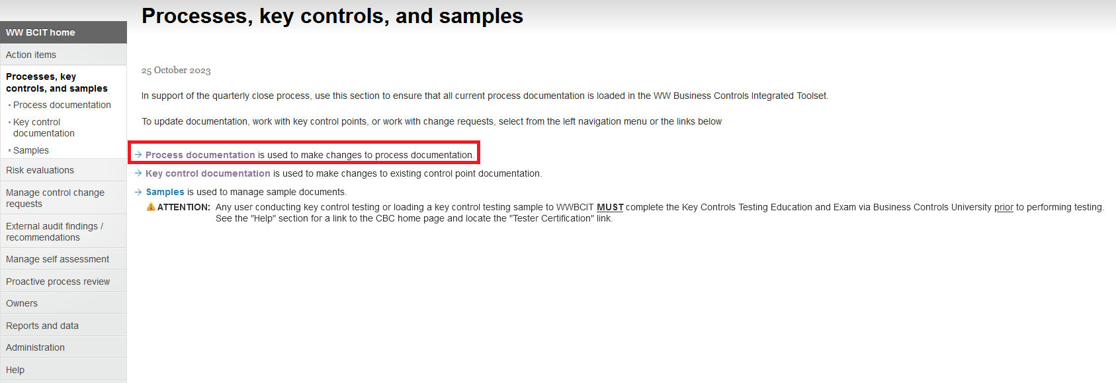

Instructions for WWBCIT
(Continued)

Finally, select “Accounts Payable” from the droplist and search using this option.
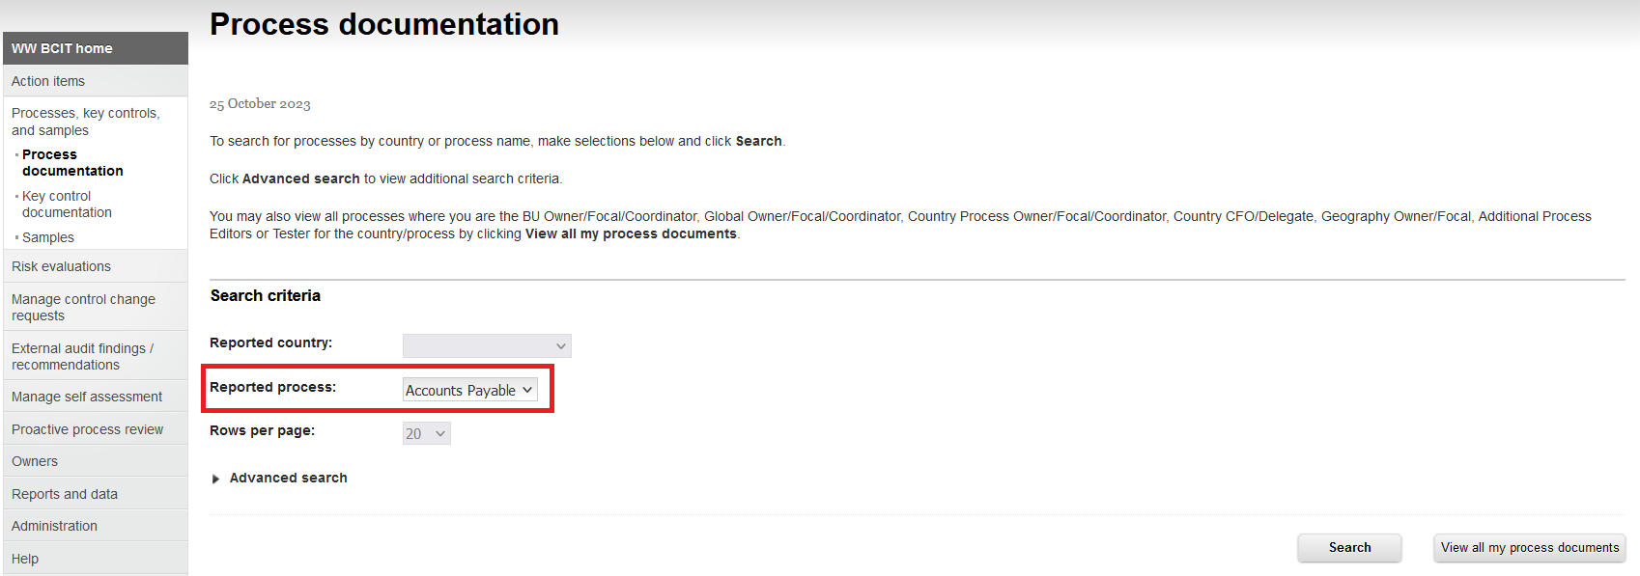

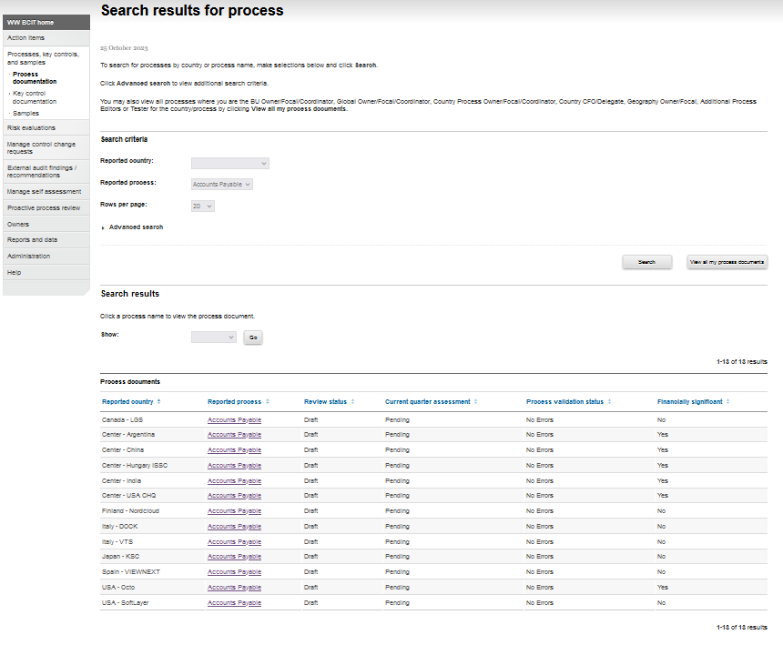

Instructions for OpenPages for BCP

Access to OpenPages using the following link: https://bcm-prod01.op.ibmcloud.com/openpages/app/jspview/react/grc/dashboard/Home
Go to “BCMS and BCP Summary”
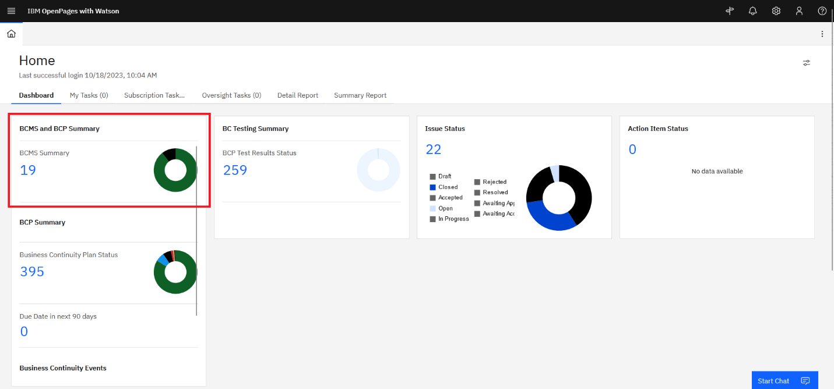

Then search by “Accounts Payable”
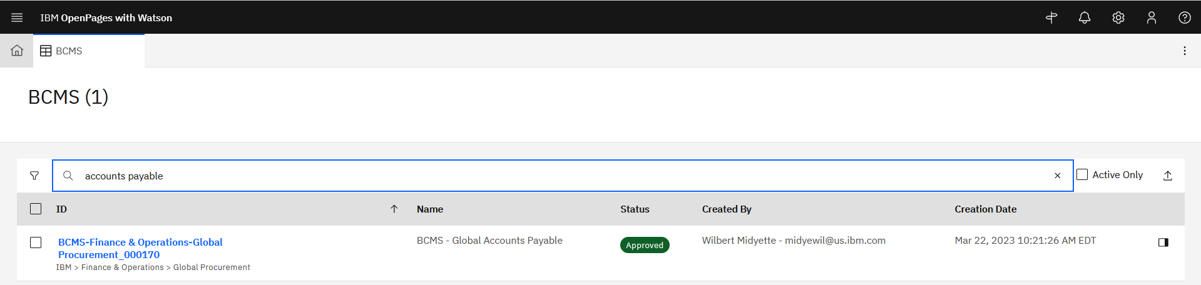

Instructions for OpenPages for BCP
(Continued)

Inside the Global Accounts Payable BCM you have to go to section “Related Objects” and you will be able to find each BCP for Accounts Payable geographies.
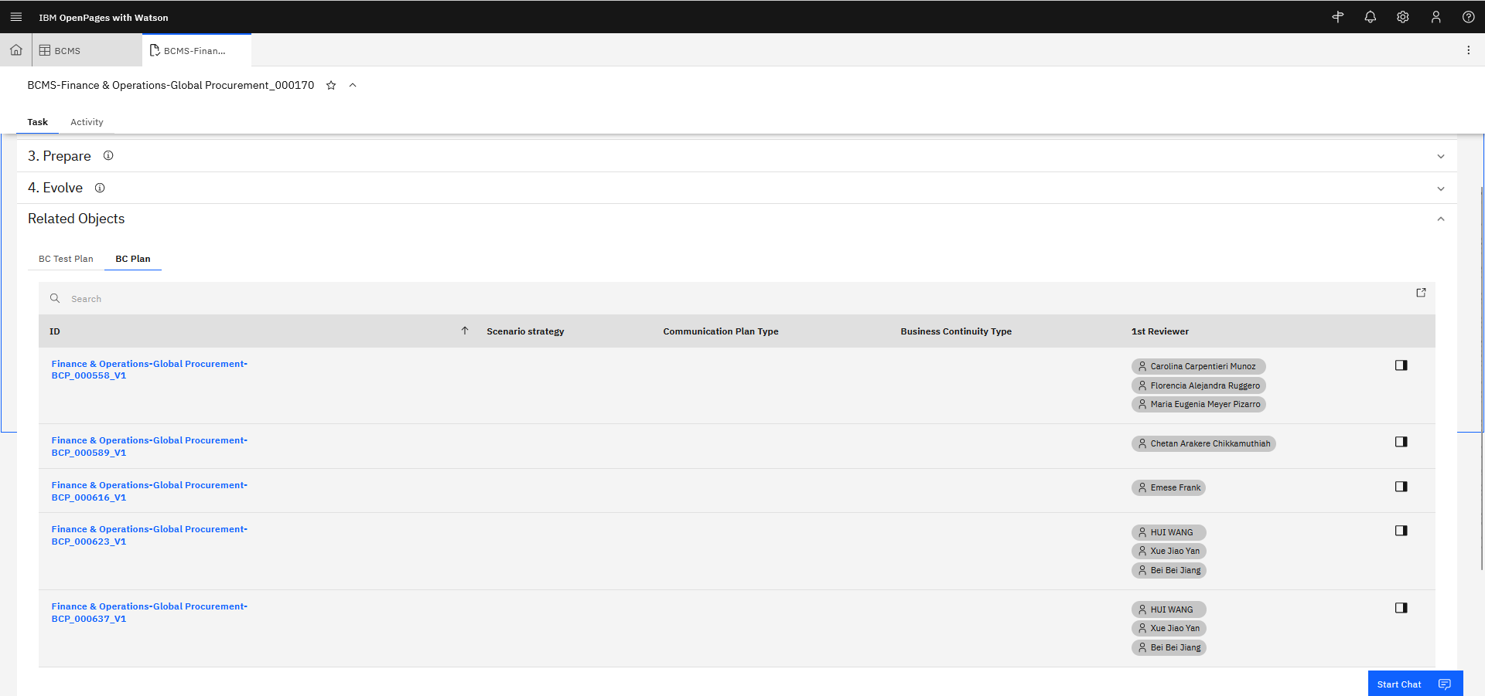

Inside each Accounts Payable BCP you have to go to section “Related Content” and you will be able to find the testing and testing result for each BCP scenario.
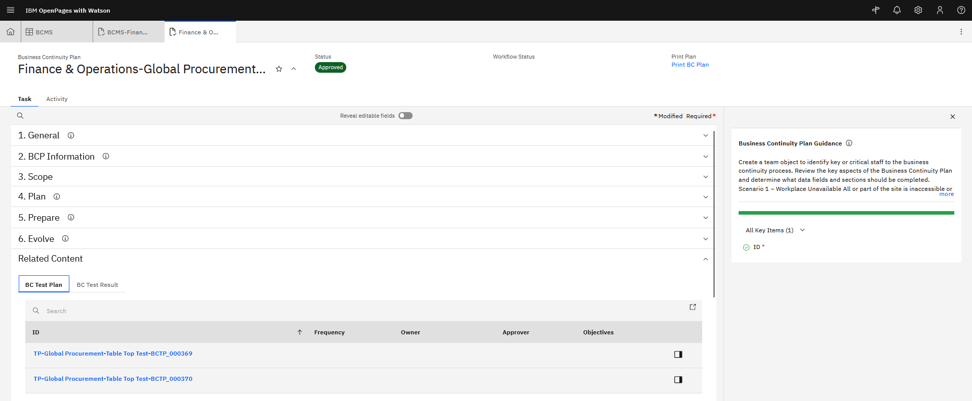

Instructions for OpenPages for BCP
(Continued)

